Gadget Mania

By

Yogesh Malik

Level-6

Final Project

Table of Contents

Project Proposal 3

Goals and Objectives 3

Project Scope 3

Project Specifications 3

Target Audience 3

Project Deliverables 4

Resource Requirements 4

Project Tasks and Milestones 4

Project Assumptions 5

Project Report 5

Detail Design 6

Home Page 6

Registration Page 6

Login Page 7

Categories Admin View 7

Suppliers Admin View 8

Products Admin View 8

All Products Visitor View 9

View Suppliers Visitor View 9

Project Testing 10

User Manual 10

Summary 10

System Configuration 10

User Access Levels 10

# 

# Project Proposal

## Goals and Objectives

The main goal or aim of the project is to implement an online web application named “Gadget Mania”. The main purpose of the application is help people to find study Gadget of different categories. In this application there are two types of users- admin and registered visitor. Admin has different functionalities as compare to registered visitor. Admin can add, edit, delete and check details of all categories, all suppliers and products of different categories.

## Project Scope

The scope of this project is to implement an app named “Gadget Mania” with the help of which user can find any categories, suppliers as well as products of different categories. The duration of the project is 20 working days which is equals to 4 weeks.

## Project Specifications

* Admin login/logout
* Add, edit, delete and check details of suppliers and products by admin.
* Admin can delete, edit and check categories.
* Admin can register new admins.
* Registered Visitor can login/logout.
* New Visitor can register.
* Visitor can categories, suppliers and products.

## Target Audience

The target audience for this project is the learner who would like to enhance knowledge about gadget of their interest. The age can go from 10 plus to 60 plus.

## Project Deliverables

The deliverables of the project are:

|  |  |
| --- | --- |
| **Deliverable** | **Description** |
| Final Report | This will be the final report of the project. |
| Coding | The executable code of the project will go under this. |
| Documentation | This portrays the documentation of the project. |
| Testing | All the test details will be covered in this part. |

## Resource Requirements

* Windows Operating System.
* Microsoft word for documentation.
* Asp.net MVC Framework
* 64-bit Processor and 4 GB or more RAM
* Identity framework- ASP

## Project Tasks and Milestones

|  |  |  |  |  |
| --- | --- | --- | --- | --- |
| **Tasks** | **Week-1** | **Week-2** | **Week-3** | **Week-4** |
| Brainstorming and analysis |  |  |  |  |
| Planning and initial meeting Project Proposal document. |  |  |  |  |
| Database Design and UI Design |  |  |  |  |
| Identity framework implementation |  |  |  |  |
| Coding for admin and reporter |  |  |  |  |
| Testing |  |  |  |  |
| Final Documentation and closing |  |  |  |  |

## Project Assumptions

Following are the assumption made while implementing the project:

* One admin and registered visitor will be registered by default.
* Application will be free and open source.

# Project Report

#### Functional and Non-Functional

|  |  |
| --- | --- |
| Users | Functional |
| Admin | * Login/logout * Register new admins * Admin can add, edit, delete, check details for categories. * Admin can edit, delete and check details for suppliers and product details. |
| Customer | * Can view details of categories and their products. * Can view the details of supplier. * New customers can register for free. * Login using valid credentials |
|  | Non- Functional |
|  | * High speed * Fast Loading time * High performance and security * All browsers compatibility. |

## Detail Design

### 

### Home Page

The main landing page of the application. On navigation bar options are- Home, All Products, Register, Login.

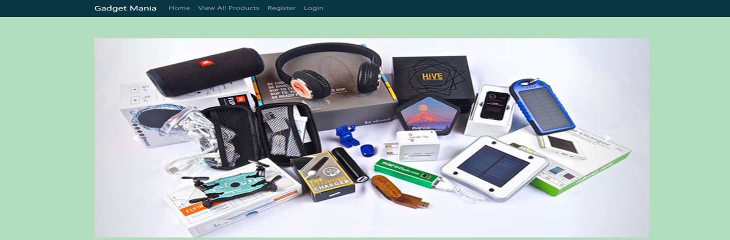

### 

### Registration Page

With the help of this page, new registered visitor can sign up for the app

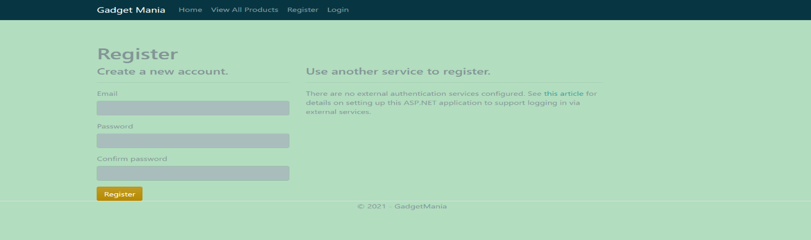

### 

### Login Page

With the help of this page, registered visitor and admin can login to the application using their valid credentials.

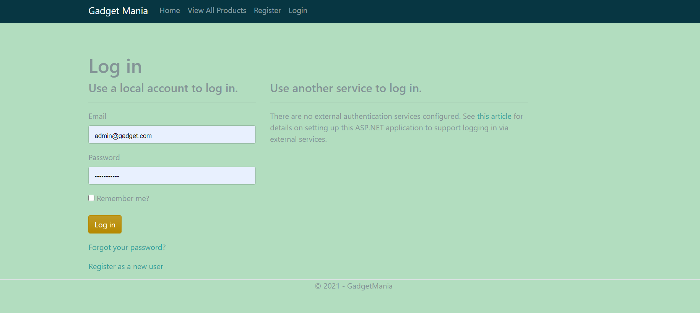

### 

### Categories Admin View

This page highlights all the Gadget Categories available on the application. Admin can add new Gadget Category, edit, delete and check details of the existing ones.

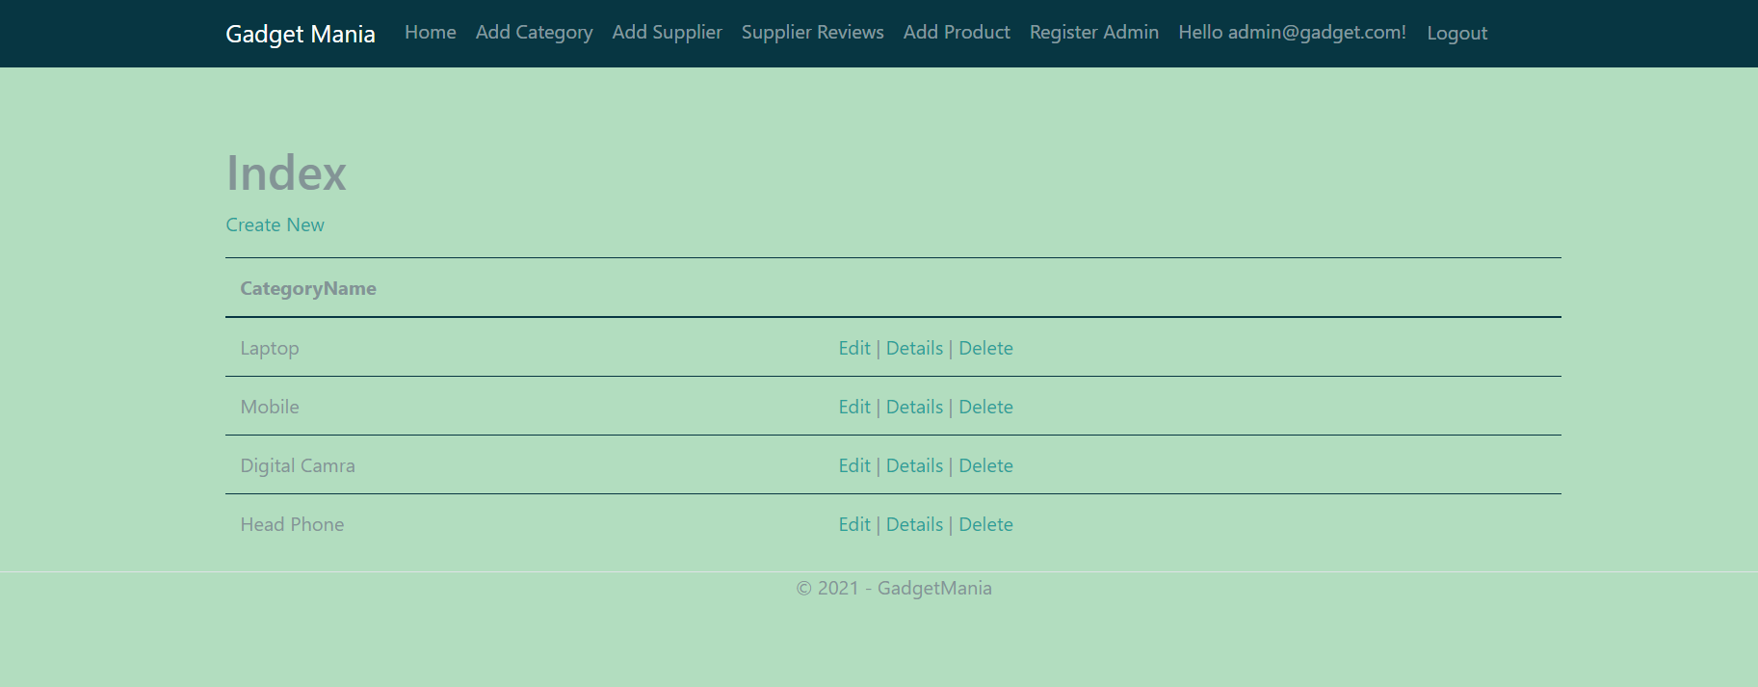

### Suppliers Admin View

With the help of this page admin can manage the Supplier details by editing, deleting and checking their details.

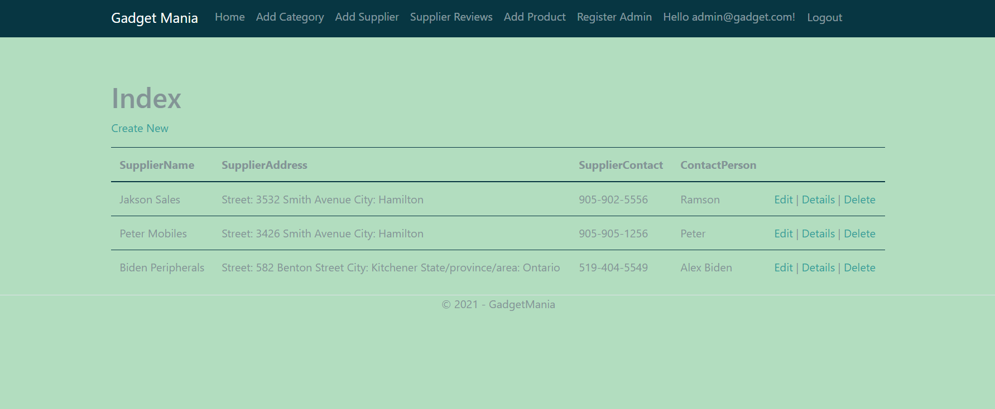

### 

### Products Admin View

With the help of this page Admin can view, add, edit and delete Products Details.

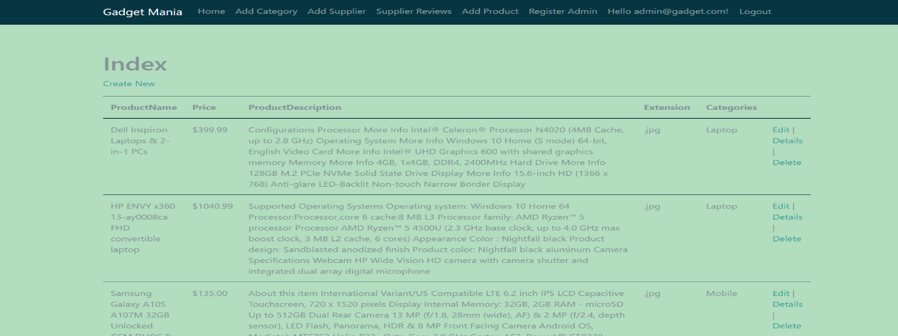

### 

### Products Visitor View

With the help of this page visitor can check the details of the Products.

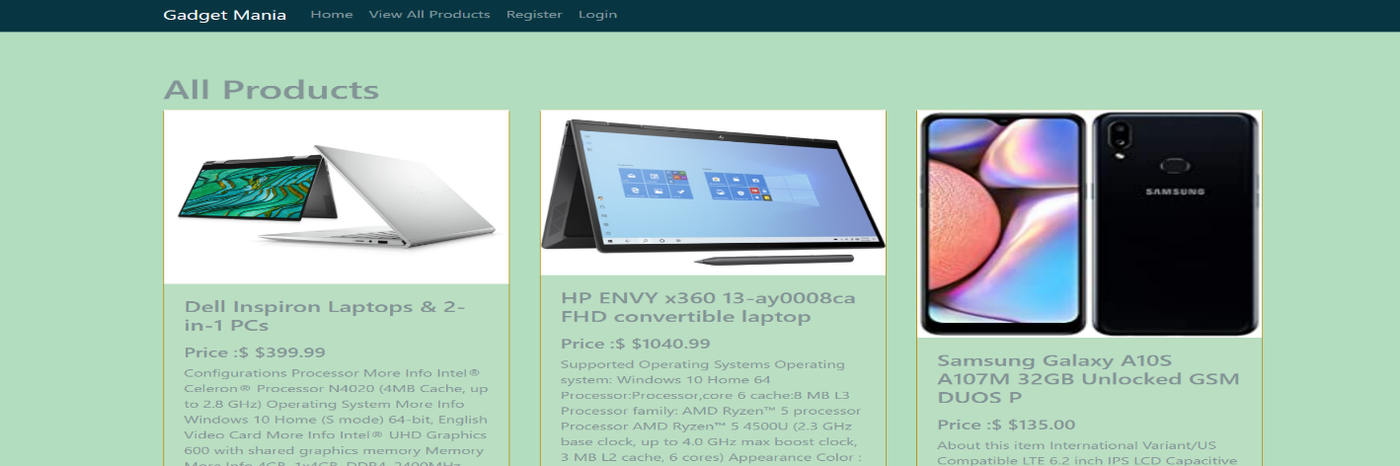

### Supplier Visitor View

This page shows the Supplier Registered View

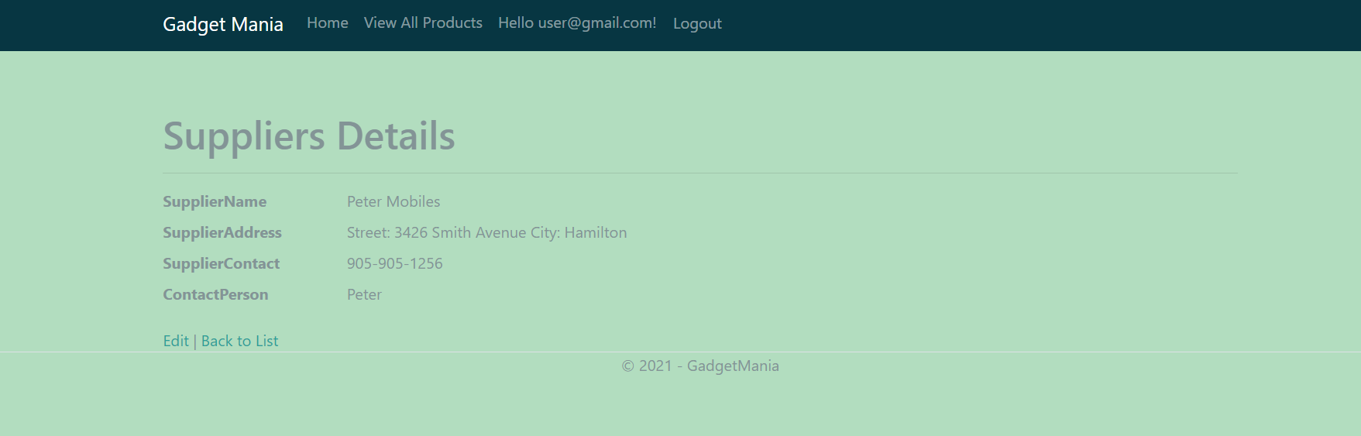

## 

## Project Testing

The testing file for usability testing is attached as [usability test.xlsx](usability%20test.xlsx)

# User Manual

The main purpose of the application Gadget Mania is to help people to find Gadget details and their supplier details. In this application there are two types of users- admin and registered user or visitor customer. Admin has different functionalities as compare to customers. Admin can add, edit, delete and check details of gadget categories. Admin can edit, delete and check details of the supplier and products entries. Also, registered user have authority to view product supplier details.

## Summary

### System Configuration

This app will be useful to for distributing information of gadget and their supplier details in presentable format.

### User Access Levels

Only registered users can access the features of this application.

* **Admin:** Admin has full access of the app can register new admins.
* **Registered Visitor:** New visitor can register and existing can login using their own credentials. They have limited access.